EX NO:01
DATE:
STARBUCKS SALES AND MARKETING ANALYSIS
AIM:
Problem Statement: Coffee Chain Sales and Marketing analysis, you are a Data Analyst working for Starbucks. The company is trying to assess marketing strategy effectiveness and sales distribution across various products they sell. You have been supplied with three data sets one for location, products and sales details in different format, and management has asked to show the following:

- Sales trend across two product categories, tea and coffee.
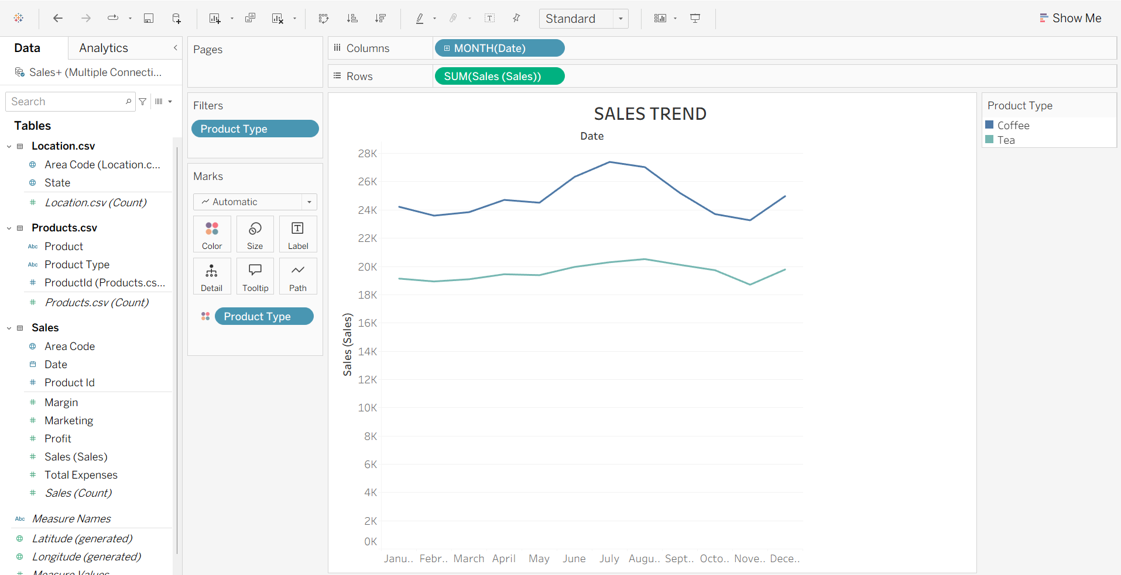

INTERPRETATION:
The chart compares monthly sales of Coffee and Tea. It helps identify changes in sales over time and compare the performance of both product types. This analysis helps understand sales trends and seasonal variations.

- Using Pie chart, show total sales distribution across product categories.

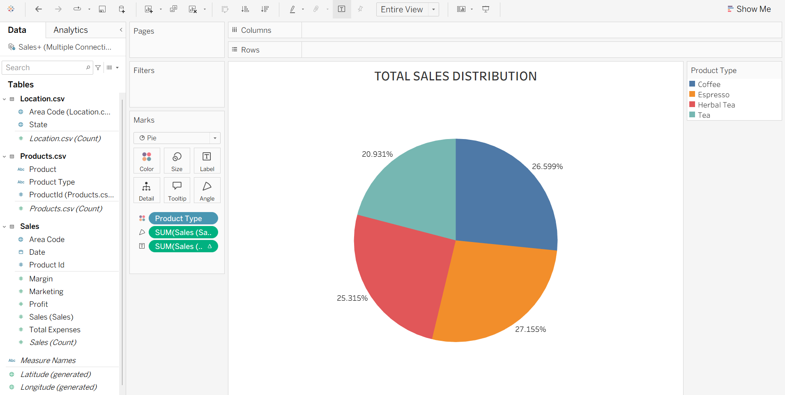

INTERPRETATION:
The pie chart represents the percentage contribution of Coffee and Tea to total sales. It helps identify which product type contributes more to overall sales and understand the sales distribution between the two categories.

- Is there any correlation between Sales and Marketing Expenses? Any changes within the years? Build a scatter plot

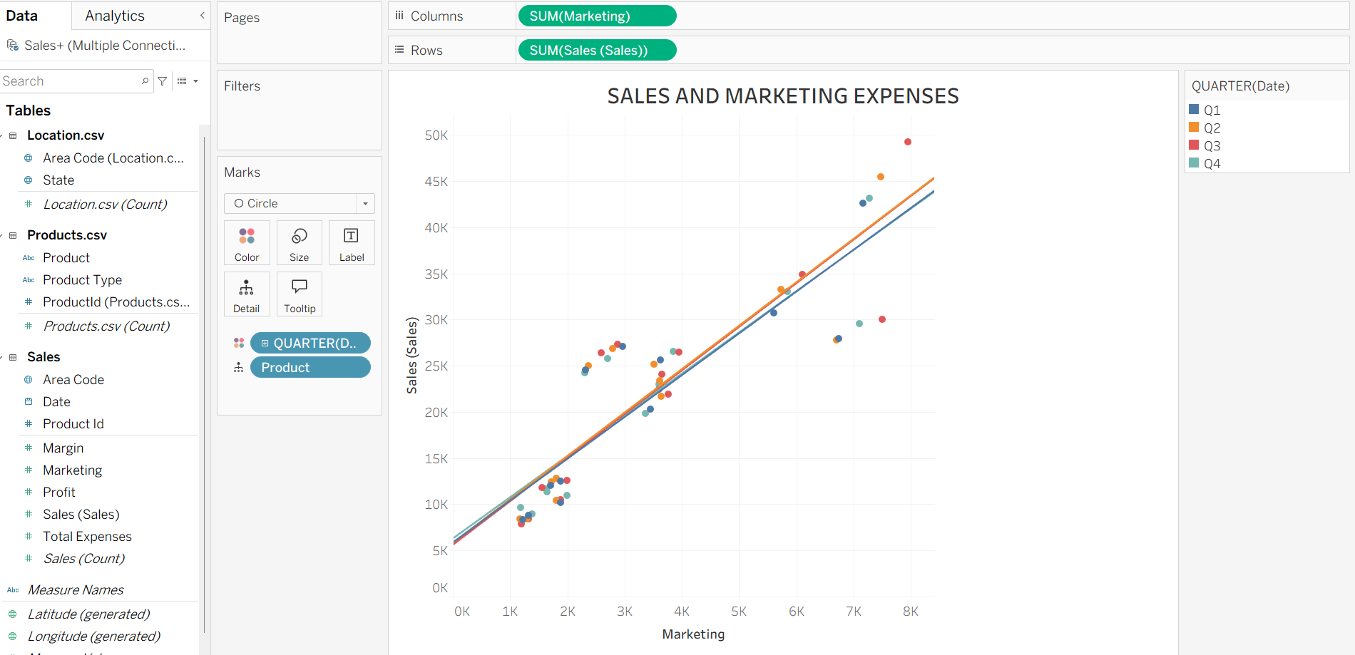

INTERPRETATION:
The scatter plot compares Sales with Marketing Expenses for different products. The trend line helps identify the relationship between marketing expenditure and sales performance. It can help determine whether higher marketing expenses are associated with higher sales.

